 

Assignment -2

|  |  |
| --- | --- |
| **Student Name/ID Number:** | I Kadek Adi Astawa/020 |
| **Academic Year:** | 2022 |
| **Unit Assessor:** |  |
| **Project Title:** | Know Your Neighborhood |
| **Issue Date:** | February 1, 2023 |
| **Submission Date:** | February 1, 2023 |
| **Internal Verifier Name:** |  |
| **Date:** |  |

|  |
| --- |
| **Learner declaration** |
| I certify that the work submitted for this assignment is my own and research sources are fully acknowledged.  February 1, 2023  Student signature: Date: |

You are developing a "Know-Your-Neighbourhood" application. The goal of this application is to provide details on all stores in the user’s neighbourhood. For this to happen, the application should have a list of stores in the town. Hence, develop Entity, Controller, Service and DAO classes to add store to the system.

**Solution :**

1. Create the Store Entity object with below fields.

a. String name

b. String phone_number

c. String [] localities // list of areas or localities the store serves

Figure 1 – Model (Store.java)

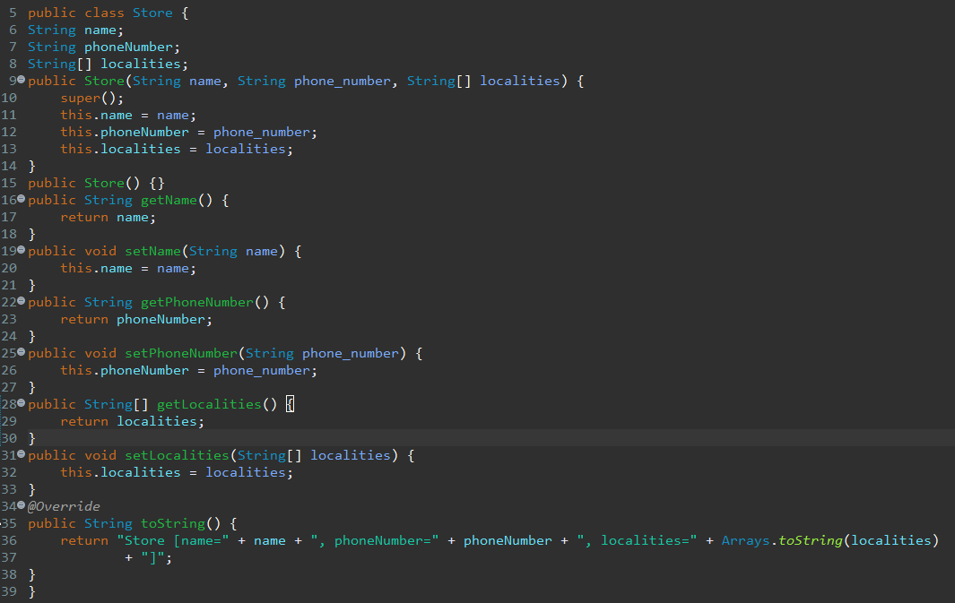

2. Develop a Controller class with a method to add Store to the system with POST HTTP method. http://:/stores

Figure 2 – Controller (StoreController.java)

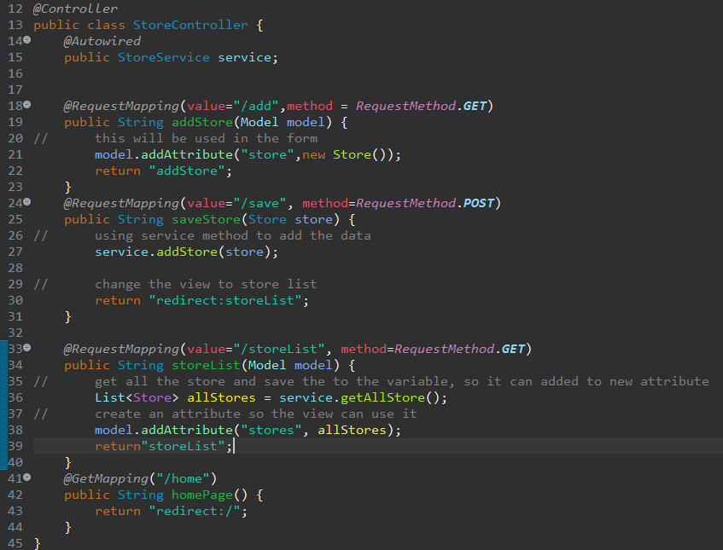

3. Develop a Service class to add Store to the repository

Figure 3 – Service (StoreService.java)

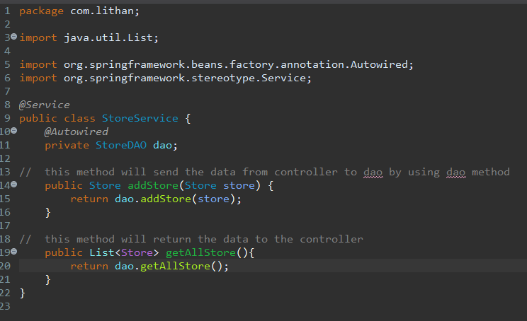

4. Develop a DAO class that just adds given store to the list of stores maintained.

a. We didn’t go through the database module yet.

b. So just maintain a list of stores as a field (i.e., member variable) in DAO class.

c. Add a store object to that list.

Figure 4 – Dao (StoreDAO.java)

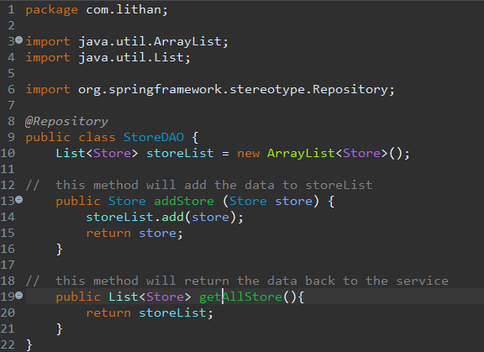

**---------------------------------Assignment 2 -- Spring MVC -- Result ----------------------------**

**Home Page**

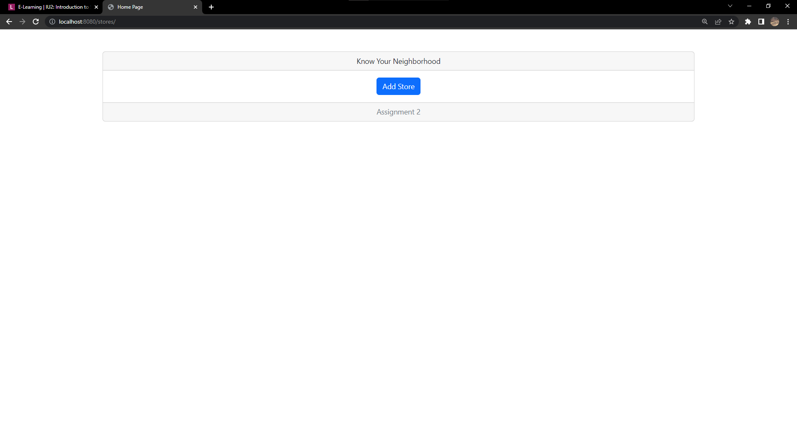

**Add Store Page**

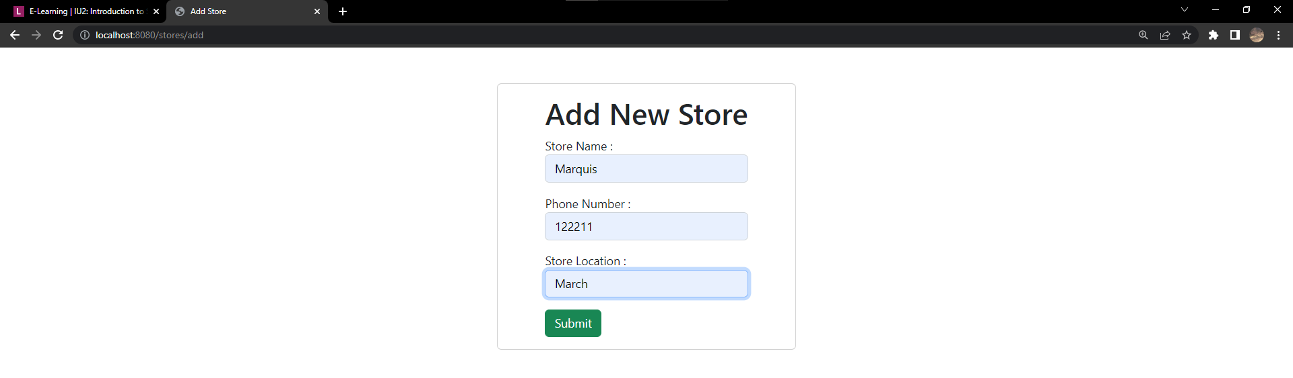

**Store List Page**

